**R.I.D.E & Startup Expo ‘25, MIT-WPU**

**Investor profiles for Wadhwani Cohort**

**Scheduled from August 11th to 13th**

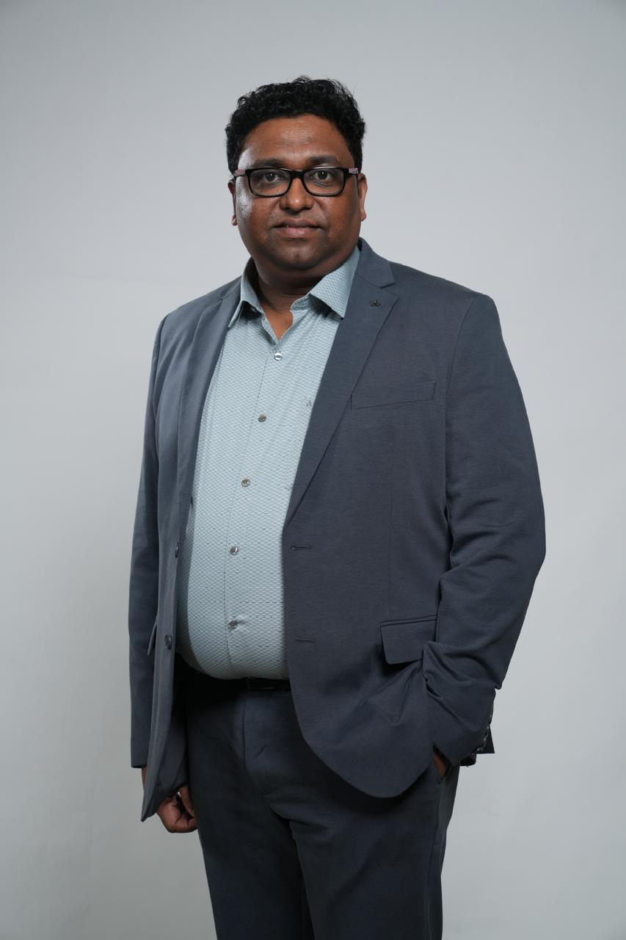

| Mr. Jiju Raman is a seasoned business leader with over 23 years of diverse experience spanning platforms, data, content, and media. Currently serving as Business Head – Consumer Services at Experian Credit Information Company India, Mr. Raman has been instrumental in driving financial inclusion by forging impactful partnerships that empower consumers to understand their credit scores and build strong credit behavior.  Mr. Raman brings a proven track record in scaling startups, leading high-performing teams, and crafting effective go-to-market strategies. His career includes leadership roles across dynamic sectors such as banking, media, telecom, and fintech, with key contributions at organizations like Locobuzz, Hungama, and Reliance ADAG (BigFlix). Across these roles, he has consistently delivered business growth, digital innovation, and sustainable profitability.  Mr. Raman offers strategic acumen, deep market foresight, and a sharp understanding of the challenges and levers that enable startups to scale in today’s competitive landscape. |
| --- |

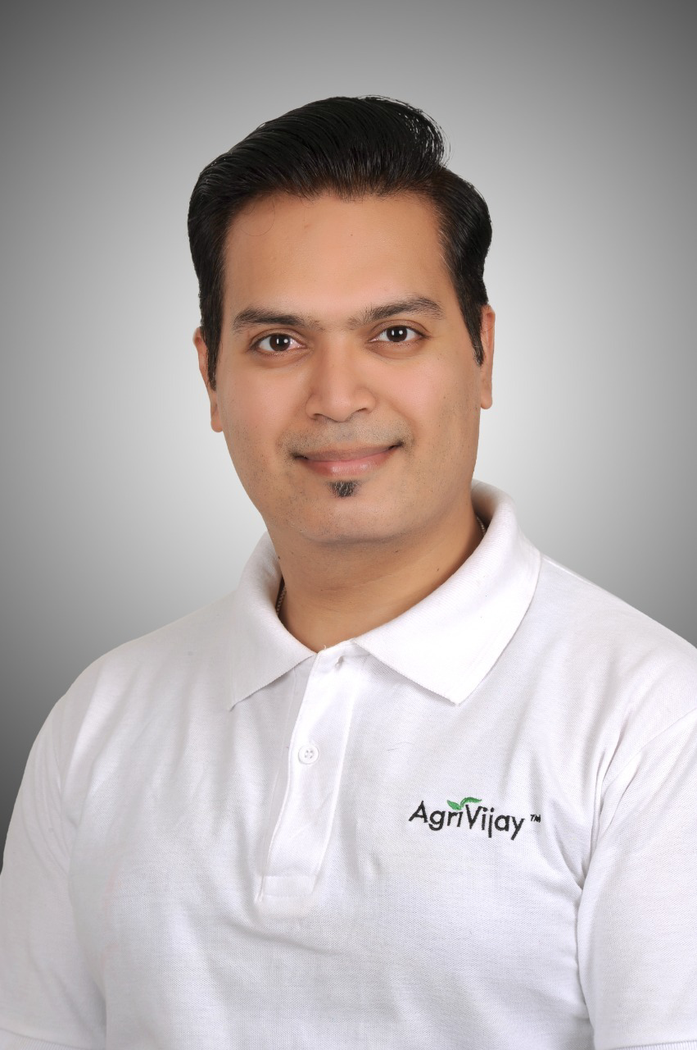

| Mr. Vimal Panjwani is proficient in leadership skills with over a decade of experience in the business industry post his Btech in the field of Bioinformatics and an MBA in the field of AgriBusiness Management. Currently the Founder and CEO AgriVijay, he has been helping to empower farmers for a tomorrow with renewable energy and a fight against climate change.  His career includes decades of experience working in the field of agriculture along with having multiple leadership roles across the fields of agriculture, renewable energy and sales in organisations such as Ugaoo, Agribolo, Global Energy Group and Sistema Biobolsa.  Mr. Panjwani offers an insight on the workings of the agriculture and renewable energy industry providing a foresight to our future as well as offering strategic and unique ways for startups to survive in today’s day and age. |
| --- |

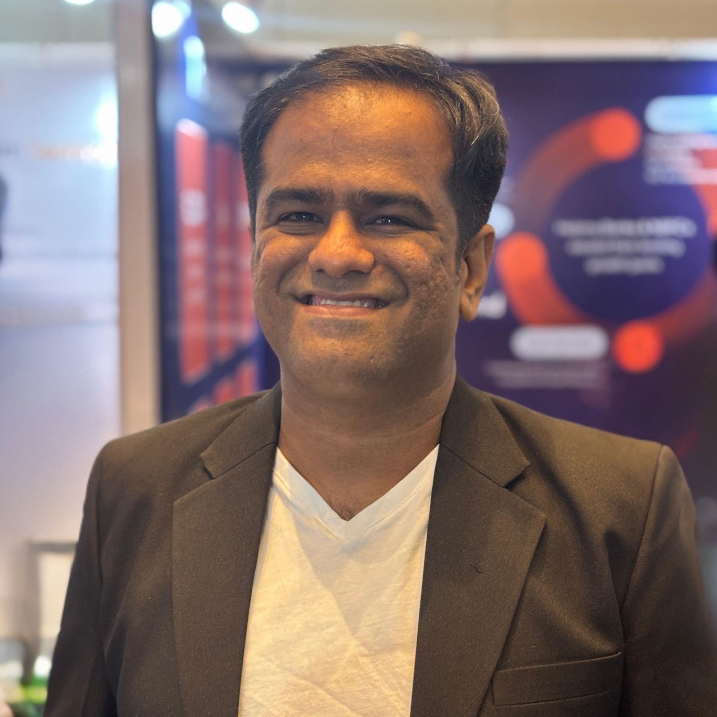

| Mr. Chirag Thakker is currently driving Alpha Seed Network, a syndicate of Angel Investors, to invest in Early-Stage Startups. He has worked with high-growth startups such as Infibeam, CarWale, UpGrad, Paysense, Livspace, and Emeritus. With over 15 years of experience in startups, his credentials reflect a deep understanding of the ecosystem. He previously founded a startup focused on Global Talent Mobility but shut it down in 2023.  Since then, he has also been actively helping startups bring their ideas to life, become investment-ready, scale their operations, and grow their businesses.His focus lies in early-stage investments, startup acceleration, venture building, and ecosystem creation with a practical, execution-driven approach. |
| --- |

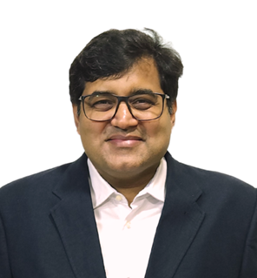

| Suketu Sangvi is a distinguished co-founder, investor, and author with over 32 years of experience at the intersection of finance and technology. A rank-holding Chartered Accountant, Company Secretary, and Mumbai University topper in computer systems, he began his career in investment banking in India and went on to work in global financial hubs like Singapore, Hong Kong, and Dubai. He has co-founded multiple tech start-ups and a regulated asset management company (Essdar Capital Group), which successfully exited in 2012.  His career spans venture capital, fund management, special situations, and structured finance, including derivatives and securitized debt. Notably, he played a pivotal role in establishing UTI Bank’s (now Axis Bank) investment banking platform. Recognized by industry awards such as Euromoney and IFR/ISR, Suketu is also a published author and a respected figure in both the finance and tech start-up ecosystems. |
| --- |

| 11th August 2025 | 1. Mr. Jiju Raman 2. Mr. Vimal Panjwani 3. Mr. Chirag Thakker 4. Mr. Suketu Sangvi |
| --- | --- |
| 12th August 2025 | 1. Mr. Jiju Raman 2. Mr. Vimal Panjwani 3. Mr. Chiarg Thakker 4. Mr. Suketu Sangvi |
| 13th August 2025 | 1. Mr. Jiju Raman 2. Mr. Vimal Panjwani 3. Mr. Chirag Thakker 4. Mr. Suketu Sangvi |